Before using the product, please read the product manual carefully
LED580BSWF CMY

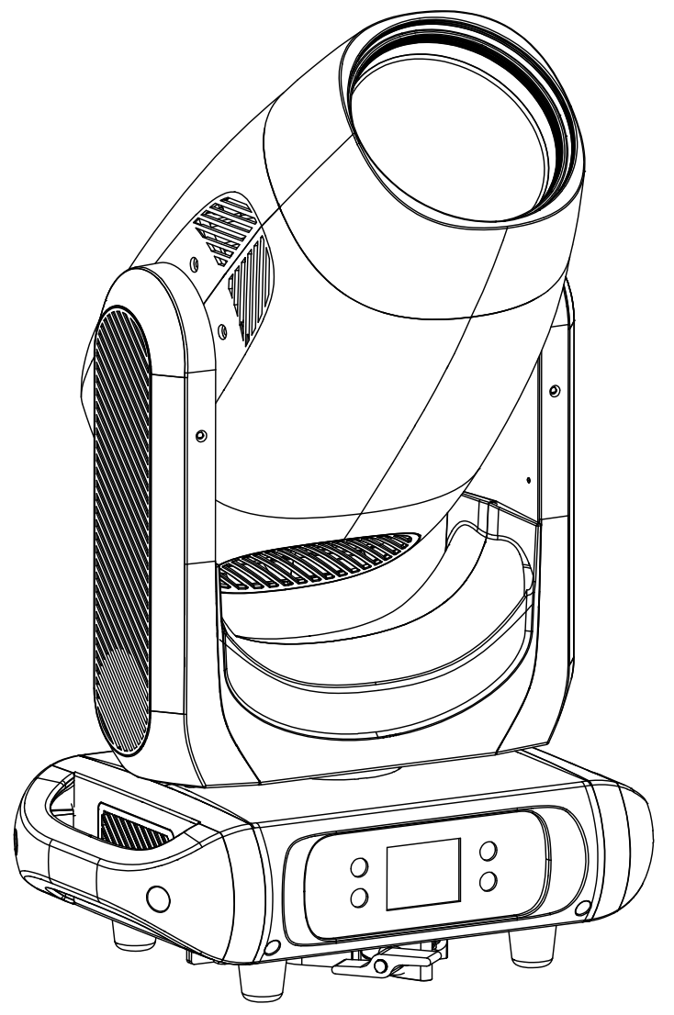

User Manual | English

CONTENTS
1. Safety warning 3
2. Packing accessories 4
3. Size and weight 4
4. Control Panel 5
5. Product Specifications 6
5.1 Light output and beam angle range 8
5.2 Pan/tilt scan 8
5.3 MENU 8
5.4 Menu control channel 12
5.5 DMX channel 13
6. Function Description 19
6.1 Color Wheels 19
6.2 Gobo Wheel 20
6.3 Gobo Replacement 20
7. Installation and connection 21
7.1 Installation diagram 21
7.3 Luminaire size after installation 22
7.4 Precautions 23
7.5 Power l Connection 23
7.6 Signal Connection 24
7.7 Signal Connection illustrate 24
7.9 Ethernet connection layout，shown as Fig. 26
7.10 DMX set 26
8. Error Information 27
9. Troubleshooting 29
10.Equipment maintenance and cleaning 31
10.1 Cleaning Precautions 31
10.2 Head filter sponge cleaning 32
10.3 Base filter sponge cleaning 32

- Safety warning


The products are packaged well when they leave the factory. Please keep the manual and read the "Installation, Use, Maintenance" and other safe operations. Equipment failure caused by man-made or irresistible reasons is not covered by the warranty.

- After receiving the lamp, please unpack and check whether there is any damage caused by transportation. If there is any damage, do not use the lamp and contact the supplier or manufacturer immediately.
- This product is suitable for indoor use, and its protection level is IP20. The lamps and lanterns should be kept clean, and should not be used in humid or dusty environments. Maintenance should be performed once or more every three months.
- Please install, use and maintain the lamps and lanterns under the operation of professionals, and operate in strict accordance with the product instructions.
- Before installing and using the lamp, please carefully check the power line and whether the signal line is damaged or damaged. When the lamp is not in use or maintained for cleaning, please unplug the power cord to prevent safety accidents.
- Make sure that the lamps work and use in a well-ventilated state, and keep a distance of at least 50cm between the product and obstacles or planes; ensure that the lamps and vents are unobstructed to avoid fire hazards caused by overheating of the lamps.
- Avoid water, liquid or solid metal objects from entering the interior of the lamp to prevent damage to the lamp or fire.
- Non-professionals, please do not open the lamp to repair by yourself; make sure that the external voltage matches the working voltage of the device before the lamp works.
- Be sure to ensure that each lamp is safely grounded, and the electrical installation complies with relevant standards to prevent electric shock.
- The product does not support direct connection to dimming devices.
- To ensure the safety of the surrounding environment, please do not place the lamps next to combustible items and explosive items to prevent fire hazards.
- If the lamp fails, please stop using it immediately and check with the power off.
- Under normal and stable operation, the surface temperature of the product should be around 70°C.
- When the lamp shell, internal accessories and lens are obviously damaged, please replace it in time.
- The distance between the lamp and the illuminated surface should be greater than 5M.
Before replacing the fuse, please disconnect the power; make sure to match the same type of fuse.

- Packing accessories
Name | QUANTITY | UNIT
Product | 1 | PCS
User Manual | 1 | PCS
Signal power line | 1 | PCS
Suspension fasteners | 1 | SET

- Size and weight
Metric system：368.3*253.9*628mm，21kgs (version with fixed clamps)
Imperial：14.5"*9.99"*24.724"in，46.297lb (version with fixed clamps)
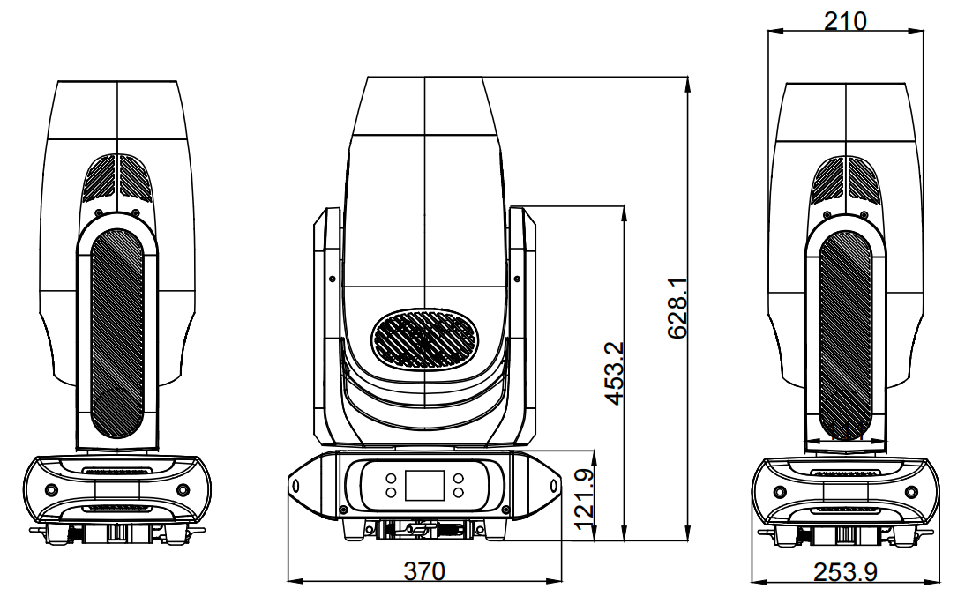
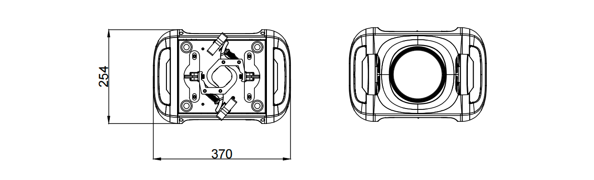
- Control Panel
POWERCON A（Standard）：
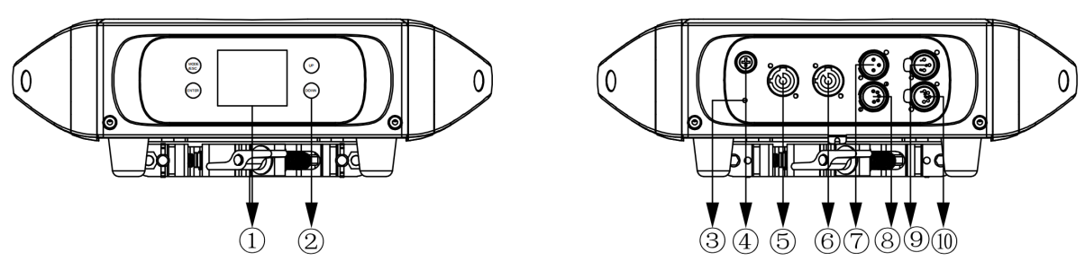
POWERCON B：
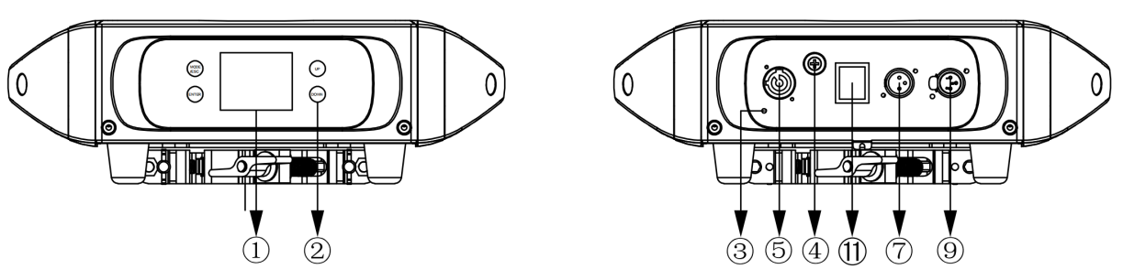

①DISPLAY：LCD Show menu functions

②TOUCH BUTTON：
Function | Illustrate | Functional description | Effect
MODE/ESC | menu selection | Enter the menu selection function | Menu operation
UP | UP | To previous selection | Changing the parameter increases
DOWN | DOWN | To the next choice | Change parameters to reduce
ENTER | ENTER | Confirm selected function | Save the last parameter
③Ground Security Screw：Lamps are safely grounded to prevent electric shock。
④FUSE：Protect lamps from damage caused by excessive current or short circuit。
⑤POWER IN：Connecting to the power supply for lamps and lanterns。
⑥POWER OUT：Connect the next light fixture。
⑦DMX IN：For DMX512 link, use 3-pin XLR cable to link the unit and controller。
⑧DMX IN：For DMX512 link, use 3-pin XLR cable to link the unit and controller。
⑨DMX OUT：For DMX512 link, use 3-pin XLR cable to link the unit and controller。
⑩DMX OUT：For DMX512 link, use 3-pin XLR cable to link the unit and controller。

⑪SWITCH：Used for lighting switching power supply function。

NOTICE：screensaver unlock password（UP DOWN UP DOWN）ENTER。

- Product Specifications
Optical parameters | SPECIFICATIONS
Light source | 450W LED
Color temperature | 7500K
Output | 15400Lm
CRI | 72
LED life | 20000H
Beam angle | 2.8°- 48°
Effect
PAN | 540°
TILT | 270°
Color | color wheel（7+open）
Color | CMY，linear
Color | 3200K~6800K，linear
Gobos | Gobos（rotating）7 interchangeable+open
Zoom | Motorized
Frost | 3° Frost
Strobe | 0 - 30Hz
Dimming | 4 dimming curves, 0~100% linear dimming
LED Refresh Rate | 800Hz，1200Hz，3600Hz，5000Hz，10KHz，15KHz，20KHz，25KHz
Dimming mode | Standard Mode, Stage Mode, TV Mode, Building Mode, Theater Mode
Prism | Rotating 5-facet prism+ rotating T-facet prism with variable speed
Electronic parameters
Mains | 100 - 240V，50/60Hz
Consumption | 220V@450W，110V@480W
Fuse | T5A，250V
Power connections | PowerCon IN/OUT
Data connections | 3pin and 5pin DMX IN/OUT
Power Factor | 0.96@220V，0.97@110V
Working environment | 0 - 45℃
Structural parameters
Dimension | 368.3*253.9*628mm
Weight | 21KG
Shell | Standard black environmentally friendly flame retardant ABS, black fine sand pattern
Installation method | Flat ground, side hanging, hanging installation
Protection level | IP20
Control
Control protocol | DMX512、RDM、sACN
Control protocol | ArtNet control（Optional）
DMX channels | Standard (36CH)/Basic (34CH)/Extended (56CH)
Accessories
Standard | Standard power signal line, safety rope, hanging parts
Optional | Flight Case

  - Light output and beam angle range
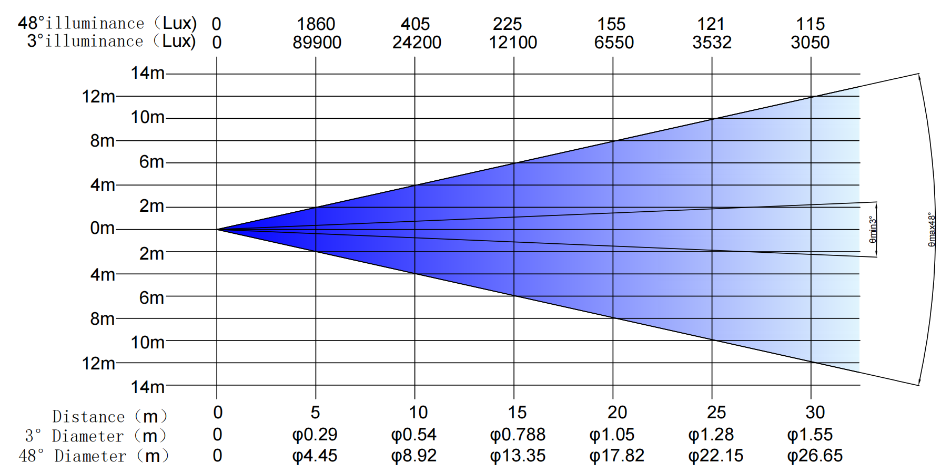
"Error

  - Pan/tilt scan
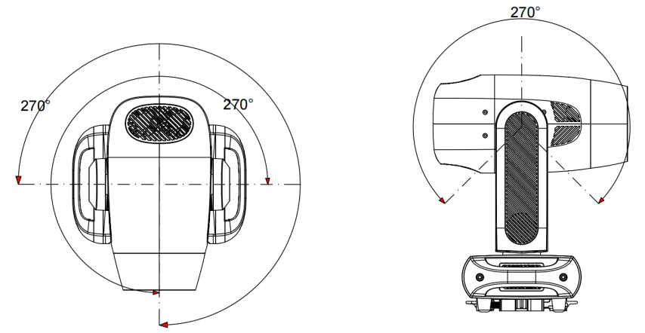
〔Pan〕 〔Tilt〕

  - MENU
MAIN MENU | SUBMENU | CHOICES 1 | CHOICES 2 | VALUES
Set config | Address | 001~512
Set config | Channel mode | Standard (36CH)
Set config | Channel mode | Basic (34CH)
Set config | Channel mode | Extended (56CH)
Set config | Mode | DMX
Set config | Mode | Slave
Set config | Mode | Auto | Auto Speed | 0~255
Set config | Mode | Sound | Sensitivity | 0~255
Set config | Fixture settings | No DMX | Blackout
Set config | Fixture settings | No DMX | Freeze
Set config | Fixture settings | Pan Reverse | OFF
Set config | Fixture settings | Pan Reverse | ON
Set config | Fixture settings | Tilt Reverse | OFF
Set config | Fixture settings | Tilt Reverse | ON
Set config | Fixture settings | Encoders | OFF
Set config | Fixture settings | Encoders | ON
Set config | Fixture settings | Display Reverse | OFF
Set config | Fixture settings | Display Reverse | ON
Set config | Fixture settings | Fan Set | Silent
Set config | Fixture settings | Fan Set | Auto
Set config | Fixture settings | Fan Set | High
Set config | Fixture settings | Dimmer Curve | Square Law
Set config | Fixture settings | Dimmer Curve | Inv SQ Law
Set config | Fixture settings | Dimmer Curve | Linear
Set config | Fixture settings | Dimmer Curve | S Curve
Set config | Fixture settings | Dimmer Speed/Mode | Standard
Set config | Fixture settings | Dimmer Speed/Mode | Stage
Set config | Fixture settings | Dimmer Speed/Mode | TV
Set config | Fixture settings | Dimmer Speed/Mode | Architecture
Set config | Fixture settings | Dimmer Speed/Mode | Theatre
Set config | Fixture settings | Dimmer Frequen | 800Hz
Set config | Fixture settings | Dimmer Frequen | 1200Hz
Set config | Fixture settings | Dimmer Frequen | 3600Hz
Set config | Fixture settings | Dimmer Frequen | 5000Hz
Set config | Fixture settings | Dimmer Frequen | 10KHz
Set config | Fixture settings | Dimmer Frequen | 15KHz
Set config | Fixture settings | Dimmer Frequen | 20KHz
Set config | Fixture settings | Dimmer Frequen | 25KHz
Set config | Fixture settings | Gobo Correction | OFF
Set config | Fixture settings |  | ON
Set config | Fixture settings | Defaults | Factory Load | OFF
 |  |  |  | ON
Set config | Fixture settings | Defaults | User Load | OFF
 |  |  |  | ON
Set config | Fixture settings | Defaults | User save | OFF
 |  |  |  | ON
Set config | Fixture settings | Language | English
Set config | Fixture settings | Language | Chinese
Set config | Fixture settings | User Time | Password | *****
Set config | Fixture settings | User Time | Time
Information | Time Info | Current Time | ***h
Information | Time Info | Total Run Time | ***h
Information | Time Info | LED Run Time | ***h
Information | Temp Unit | Celsius
Information | Temp Unit | Fahrenheit
Information | Error Info | No Error Record
Information | Model Info
Information | Software Ver | V1.00
Manual | Test | OFF
Manual | Test | ON
Manual | Manual Control | Pan | 0~255
Manual | Manual Control | Pan Fine | 0~255
Manual | Manual Control | Tilt | 0~255
Manual | Manual Control | Tile Fine | 0~255
Manual | Manual Control | Pan/Tilt Speed | 0~255
Manual | Manual Control | Strobe | 0~255
Manual | Manual Control | Dimmer | 0~255
Manual | Manual Control | Reserved | 0~255
Manual | Manual Control | Reserved | 0~255
Manual | Manual Control | Reserved | 0~255
Manual | Manual Control | Zoom | 0~255
Manual | Manual Control | Focus | 0~255
Manual | Manual Control | Auto Focus | 0~255
Manual | Manual Control | Auto Focus Fine | 0~255
Manual | Manual Control | Color Wheel | 0~255
Manual | Manual Control | Cyan | 0~255
Manual | Manual Control | Magenta | 0~255
Manual | Manual Control | Yellow | 0~255
Manual | Manual Control | CTO | 0~255
Manual | Manual Control | Rot Gobo Wheel | 0~255
Manual | Manual Control | Gobo Rot | 0~255
Manual | Manual Control | Reserved | 0~255
Manual | Manual Control | Iris | 0~255
Manual | Manual Control | Prism | 0~255
Manual | Manual Control | Prism Rot | 0~255
Manual | Manual Control | Frost | 0~255
Manual | Manual Control | Blade 1A | 0~255
Manual | Manual Control | Blade 1B | 0~255
Manual | Manual Control | Blade 2A | 0~255
Manual | Manual Control | Blade 2B | 0~255
Manual | Manual Control | Blade 3A | 0~255
Manual | Manual Control | Blade 3B | 0~255
Manual | Manual Control | Blade 4A | 0~255
Manual | Manual Control | Blade 4B | 0~255
Manual | Manual Control | AllBlade Rot | 0~255
Manual | Reset | All
Manual | Reset | Pan&Tilt
Manual | Reset | Color
Manual | Reset | Gobo
Manual | Reset | Other
Calibrate | Password(008) | ***(008)
Calibrate | Password(008) | Pan | 0~25
Calibrate | Password(008) | Tilt | 0~25
Calibrate | Password(008) | Color Wheel | 0~25
Calibrate | Password(008) | Cyan | 0~25
Calibrate | Password(008) | Magenta | 0~25
Calibrate | Password(008) | Yellow | 0~25
Calibrate | Password(008) | Rot Gobo Wheel | 0~25
Calibrate | Password(008) | Gobo Rot | 0~25
Calibrate | Password(008) | Zoom | 0~25
Calibrate | Password(008) | Focus | 0~25
Calibrate | Password(008) | Iris | 0~25
Calibrate | Password(008) | Prism | 0~25
Calibrate | Password(008) | Prism Rot | 0~25
Calibrate | Password(008) | Frost | 0~25
Calibrate | Password(008) | Blade 1A | 0~25
Calibrate | Password(008) | Blade 1B | 0~25
Calibrate | Password(008) | Blade 2A | 0~25
Calibrate | Password(008) | Blade 2B | 0~25
Calibrate | Password(008) | Blade 3A | 0~25
Calibrate | Password(008) | Blade 3B | 0~25
Calibrate | Password(008) | Blade 4A | 0~25
Calibrate | Password(008) | Blade 4B | 0~25
Calibrate | Password(008) | AllBlade Rot | 0~25

  - Menu control channel
CONTROL CHANNEL
CH | Standard (36CH) | Basic (34CH) | Extended (56CH)
1 | Pan | Pan | Pan
2 | Pan Fine | Tilt | Pan Fine
3 | Tilt | Speed Pan/Tilt | Tilt
4 | Tilt Fine | Shutter | Tilt Fine
5 | Speed Pan/Tilt | Dimmer | Speed Pan/Tilt
6 | Shutter | Reserved | Shutter
7 | Dimmer | Reserved | Dimmer
8 | Reserved | Reserved | Dimmer Fine
9 | Reserved | Zoom | Reserved
10 | Reserved | Focus | Reserved
11 | Zoom | Auto Focus | Reserved
12 | Focus | Auto Focus Fine | Zoom
13 | Auto Focus | Color Wheel | Zoom Fine
14 | Auto Focus Fine | Cyan Color | Focus
15 | Color Wheel | Magenta Color | Focus Fine
16 | Cyan Color | Yellow Color | Auto Focus
17 | Magenta Color | CTO Color | Auto Focus Fine
18 | Yellow Color | Rotating gobo | Color Wheel
19 | CTO Color | Rotating gobo index | Color Wheel Fine
20 | Rotating gobo | Reserved | Cyan Color
21 | Rotating gobo index | Iris | Cyan Color Fine
22 | Reserved | Prism | Magenta Color
23 | Iris | Rotating prism | Magenta Color Fine
24 | Prism | Frost | Yellow Color
25 | Rotating prism | Blade 1A | Yellow Color Fine
26 | Frost | Blade 1B | CTO Color
27 | Blade 1A | Blade 2A | CTO Color Fine
28 | Blade 1B | Blade 2B | Rotating gobo
29 | Blade 2A | Blade 3A | Rotating gobo index
30 | Blade 2B | Blade 3B | Rotating gobo index Fine
31 | Blade 3A | Blade 4A | Reserved
32 | Blade 3B | Blade 4B | Iris
33 | Blade 4A | All Blade Rotation | Iris Fine
34 | Blade 4B | Reset、LCD、Fans | Prism
35 | All Blade Rotation |  | Rotating prism
36 | Reset、LCD、Fans |  | Rotating prism Fine
37 |  |  | Frost
38 |  |  | Blade 1A
39 |  |  | Blade 1A Fine
40 |  |  | Blade 1B
41 |  |  | Blade 1B Fine
42 |  |  | Blade 2A
43 |  |  | Blade 2A Fine
44 |  |  | Blade 2B
45 |  |  | Blade 2B Fine
46 |  |  | Blade 3A
47 |  |  | Blade 3A Fine
48 |  |  | Blade 3B
49 |  |  | Blade 3B Fine
50 |  |  | Blade 4A
51 |  |  | Blade 4A Fine
52 |  |  | Blade 4B
53 |  |  | Blade 4B Fine
54 |  |  | All Blade Rotation
55 |  |  | All Blade Rotation Fine
56 |  |  | Reset、LCD、Fans

  - DMX channel
DMX channel´s functions and their values (56DMX channels):
Mode/Channel |  |  | Value | Function
St | Ba | Ex | Value
36CH | 34CH | 56CH | Value
1 | 1 | 1 |  | PAN Movement 8bit :
1 | 1 | 1 | 0-255 | Pan Movement
2 |  | 2 |  | Pan Fine 16bit
2 |  | 2 | 0-255 | Fine control of Pan movement
3 | 2 | 3 |  | TILT Movement 8bit :
3 | 2 | 3 | 0-255 | Tilt Movement
4 |  | 4 |  | Tilt Fine 16bit
4 |  | 4 | 0-255 | Fine control of Tilt movement
5 | 3 | 5 |  | Speed Pan/Tilt movement:
5 | 3 | 5 | 0-225 | max to min speed
5 | 3 | 5 | 226-235 | blackout by movement
5 | 3 | 5 | 236-245 | blackout by all wheel changing
5 | 3 | 5 | 246-255 | no function
6 | 4 | 6 |  | Shutter, strobe:
6 | 4 | 6 | 00-10 | Shutter closed
6 | 4 | 6 | 11-20 | No function (shutter open)
6 | 4 | 6 | 21-117 | Strobe effect slow to fast
6 | 4 | 6 | 118-126 | No function (shutter open)
6 | 4 | 6 | 127-180 | Pulse-effect in sequences
6 | 4 | 6 | 181-191 | No function (shutter open)
6 | 4 | 6 | 192-245 | Random strobe effect slow to fast
6 | 4 | 6 | 246-255 | No function (shutter open)
7 | 5 | 7 |  | Dimmer intensity:
7 | 5 | 7 | 0-255 | Intensity 0 to 100%
 |  | 8 |  | Fine Dimmer intensity:
 |  | 8 | 0-255 | Dimmer intensity fine
8 | 6 | 9 |  | Reserved
9 | 7 | 10 |  | Reserved
10 | 8 | 11 |  | Reserved
11 | 9 | 12 |  | Zoom :
11 | 9 | 12 | 0-255 | Zoom adjustment from small to big
 |  | 13 |  | Zoom Fine:
 |  | 13 | 0-255 | Zoom adjustment Fine
12 | 10 | 14 |  | Focus :
12 | 10 | 14 | 0-255 | Continuous adjustment from near to far
 |  | 15 |  | Focus Fine:
 |  | 15 | 0-255 | Continuous adjustment Fine
13 | 11 | 16 |  | Auto Focus :
13 | 11 | 16 | 0-50 | Auto Focus Off
13 | 11 | 16 | 51-100 | 5m
13 | 11 | 16 | 101-150 | 7.5m
13 | 11 | 16 | 151-200 | 10m
13 | 11 | 16 | 201-255 | 15m
14 | 12 | 17 |  | AutoFocus Fine:
14 | 12 | 17 | 0-255 | Continuous adjustment Fine
15 | 13 | 18 |  | Color Wheel:
15 | 13 | 18 | 00-3 | Open / white
15 | 13 | 18 | 4-7 | Color 1(CTB) |             
15 | 13 | 18 | 8-11 | Color 2(Magenta)
15 | 13 | 18 | 12-15 | Color 3(Congo Blue)
15 | 13 | 18 | 16-19 | Color 4(Green)
15 | 13 | 18 | 20-23 | Color 5(Orange)
15 | 13 | 18 | 24-27 | Color 6(Light Blue)
15 | 13 | 18 | 28-31 | Color 7(Red)
15 | 13 | 18 | 32-127 | Color indexing
15 | 13 | 18 | 128-189 | Forwards rainbow effect from fast to slow
15 | 13 | 18 | 190-193 | No rotation
15 | 13 | 18 | 194-255 | Backwards rainbow effect from slow to fast
 |  | 19 |  | Color Wheel Fine :
 |  | 19 | 0-255 | Color Wheel colour change to any position Fine
16 | 14 | 20 |  | Cyan Color :
16 | 14 | 20 | 0-255 | Cyan (0-white, 255-100% Cyan)
 |  | 21 |  | Cyan Color Fine :
 |  | 21 | 0-255 | Cyan Fine
17 | 15 | 22 |  | Magenta Color :
17 | 15 | 22 | 0-255 | Magenta (0-white, 255-100% magenta)
 |  | 23 |  | Magenta Color Fine :
 |  | 23 | 0-255 | Magenta Fine
18 | 16 | 24 |  | Yellow Color :
18 | 16 | 24 | 0-255 | Yellow (0-white, 255-100% Yellow)
 |  | 25 |  | Yellow Color Fine :
 |  | 25 | 0-255 | Yellow Fine
19 | 17 | 26 |  | CTO Color :
19 | 17 | 26 | 0-255 | CTO (0-white, 255-100% CTO)
 |  | 27 |  | CTO Color Fine :
 |  | 27 | 0-255 | CTO Fine
20 | 18 | 28 |  | Rotating gobos, cont. rotation 1:
20 | 18 | 28 | 00-9 | Open
20 | 18 | 28 | 10-19 | Rot. gobo 1 | 
20 | 18 | 28 | 20-29 | Rot. gobo 2
20 | 18 | 28 | 30-39 | Rot. gobo 3
20 | 18 | 28 | 40-49 | Rot. gobo 4
20 | 18 | 28 | 50-59 | Rot. gobo 5
20 | 18 | 28 | 60-69 | Rot. gobo 6
20 | 18 | 28 | 70-77 | Rot. Gobo 7
20 | 18 | 28 | 78-93 | Gobo 1 shake slow to fast
20 | 18 | 28 | 94-109 | Gobo 2 shake slow to fast
20 | 18 | 28 | 110-125 | Gobo 3 shake slow to fast
20 | 18 | 28 | 126-141 | Gobo 4 shake slow to fast
20 | 18 | 28 | 142-157 | Gobo 5 shake slow to fast
20 | 18 | 28 | 158-173 | Gobo 6 shake slow to fast
20 | 18 | 28 | 174-189 | Gobo 7 shake slow to fast
20 | 18 | 28 | 190-221 | Gobo wheel rotation forwards from fast to slow
20 | 18 | 28 | 222-223 | No rotation
20 | 18 | 28 | 224-255 | Gobo wheel rotation f backwards from slow to fast
21 | 19 | 29 |  | Rotating gobo index,rotating gobo rotation 1:
21 | 19 | 29 | 0-127 | Gobo indexing
21 | 19 | 29 | 128-189 | Forwards gobo rotation from fast to slow
21 | 19 | 29 | 190-193 | No rotation
21 | 19 | 29 | 194-255 | Backwards gobo rotation from slow to fast
 |  | 30 |  | Rotating gobo indexing Fine 1:
 |  | 30 | 0-255 | Fine indexing
22 | 20 | 31 | 0-255 | Reserved
23 | 21 | 32 |  | Iris:
23 | 21 | 32 | 0-191 | Max. diameter to Min.diameter
23 | 21 | 32 | 192-223 | Pulse closing fast to slow
23 | 21 | 32 | 224-255 | Pulse opening slow to fast
 |  | 33 |  | Iris Fine:
 |  | 33 | 0-255 | Iris Fine
24 | 22 | 34 |  | Prism:
24 | 22 | 34 | 0-127 | Open
24 | 22 | 34 | 128-255 | 5-Facet Prism | 
25 | 23 | 35 |  | Rotating prism index, rotating prism rotation
25 | 23 | 35 | 0-127 | Prism indexing
25 | 23 | 35 | 128-189 | Forwards prism rotation from fast to slow
25 | 23 | 35 | 190-193 | No rotation
25 | 23 | 35 | 194-255 | Backwards prism rotation from slow to fast
 |  | 36 |  | Rotating prism indexing Fine :
 |  | 36 | 0-255 | Fine indexing
26 | 24 | 37 |  | Frost:
26 | 24 | 37 | 0-255 | 0-100% Frost
27 | 25 | 38 |  | Blade 1A :
27 | 25 | 38 | 0-255 | Open to Close
 |  | 39 |  | Blade 1A Fine :
 |  | 39 | 0-255 | Open to Close Fine
28 | 26 | 40 |  | Blade 1B :
28 | 26 | 40 | 0-255 | Open to Close
 |  | 41 |  | Blade 1B Fine :
 |  | 41 | 0-255 | Open to Close Fine
29 | 27 | 42 |  | Blade 2A :
29 | 27 | 42 | 0-255 | Open to Close
 |  | 43 |  | Blade 2A Fine :
 |  | 43 | 0-255 | Open to Close Fine
30 | 28 | 44 |  | Blade 2B :
30 | 28 | 44 | 0-255 | Open to Close
 |  | 45 |  | Blade 2B Fine :
 |  | 45 | 0-255 | Open to Close Fine
31 | 29 | 46 |  | Blade 3A:
31 | 29 | 46 | 0-255 | Open to Close
 |  | 47 |  | Blade 3A Fine :
 |  | 47 | 0-255 | Open to Close Fine
32 | 30 | 48 |  | Blade 3B :
32 | 30 | 48 | 0-255 | Open to Close
 |  | 49 |  | Blade 3B Fine :
 |  | 49 | 0-255 | Open to Close Fine
33 | 31 | 50 |  | Blade 4A :
33 | 31 | 50 | 0-255 | Open to Close
 |  | 51 |  | Blade 4A Fine :
 |  | 51 | 0-255 | Open to Close Fine
34 | 32 | 52 |  | Blade 4B :
34 | 32 | 52 | 0-255 | Open to Close
 |  | 53 |  | Blade 4B Fine :
 |  | 53 | 0-255 | Open to Close Fine
35 | 33 | 54 |  | All Blade Rotation :
35 | 33 | 54 | 0-255 | All Blade Rotation
 |  | 55 |  | All Blade Rotation Fine :
 |  | 55 | 0-255 | All Blade Rotation Fine
36 | 34 | 56 |  | Control, reset, internal programs:
36 | 34 | 56 | 00-4 | unused
36 | 34 | 56 | 5-9 | Display Off
36 | 34 | 56 | 10-14 | Display On
36 | 34 | 56 | 15-19 | Display Invert Off
36 | 34 | 56 | 20-24 | Display Invert On
36 | 34 | 56 | 25-26 | Auto fan control mode
36 | 34 | 56 | 27-28 | Stage fan control mode
36 | 34 | 56 | 29-30 | Silence fan control mode
36 | 34 | 56 | 31-32 | Super Silence fan control mode
36 | 34 | 56 | 33-34 | Constant Fans Off
36 | 34 | 56 | 35-36 | Constant Fans On
36 | 34 | 56 | 37-44 | unused
36 | 34 | 56 | 45-49 | Square Law
36 | 34 | 56 | 50-54 | Linear
36 | 34 | 56 | 55-58 | 1.2K
36 | 34 | 56 | 59-62 | 2.4K
36 | 34 | 56 | 63-66 | 16K
36 | 34 | 56 | 67-69 | 25K
36 | 34 | 56 | 70-74 | Gobo correction Off
36 | 34 | 56 | 75-79 | Gobo correction On
36 | 34 | 56 | 80-84 | All motor reset
36 | 34 | 56 | 85-87 | Scan motor reset
36 | 34 | 56 | 88-90 | Colors motor reset
36 | 34 | 56 | 91-93 | Gobo motor reset
36 | 34 | 56 | 94-96 | unused
36 | 34 | 56 | 97-99 | Other motor reset
36 | 34 | 56 | 100-119 | unused
36 | 34 | 56 | 120-139 | unused
36 | 34 | 56 | 140-159 | unused
36 | 34 | 56 | 160-179 | unused
36 | 34 | 56 | 180-199 | unused
36 | 34 | 56 | 200-219 | unused
36 | 34 | 56 | 220-239 | unused
36 | 34 | 56 | 240-255 | unused

- Function Description
  - Color Wheels
A：The color chip wheel consists of 7 high-standard fixed colors, which are composed as follows. When used with the pattern wheel, colorful pattern effects can be changed at will.
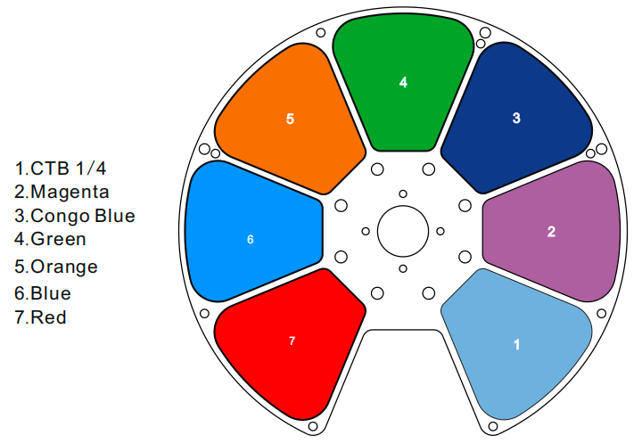
B：CMY+CTO linear

  - Gobo Wheel
As shown in（Fig.6.2-1），1 rotating gobo with 7 gobos.
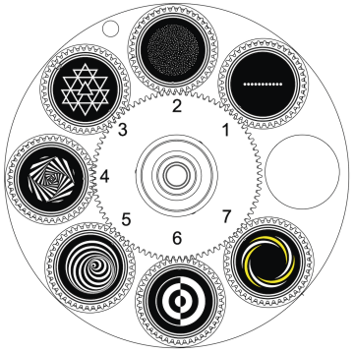
rotating gobo（Fig.6.2-1）

6.3 Gobo Replacement
Danger!
Please disconnect the power when installing/replacing the rotating gobo!

①Pull out the communication cable and signal transfer cable, unscrew the four screws at A with a screwdriver, and take out the component；
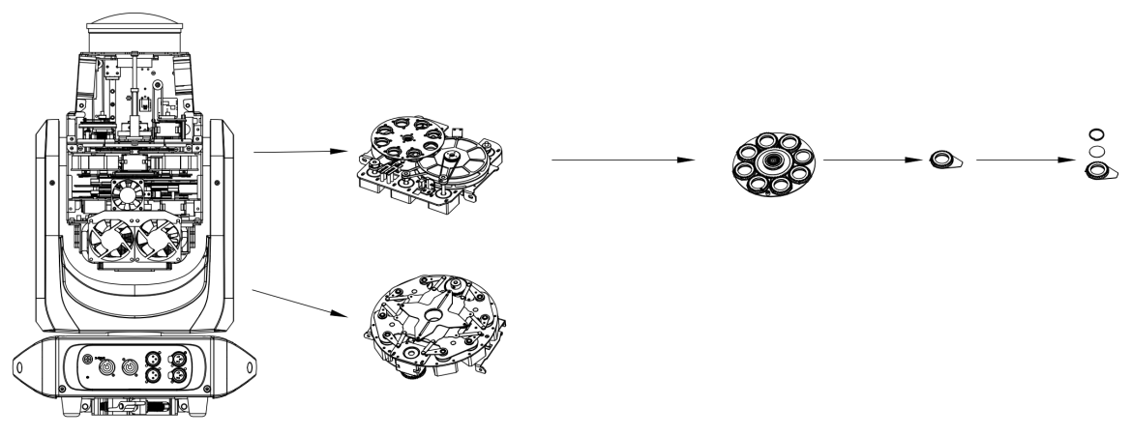
A
② As shown in the figure below, gently lift the gobo driven wheel from the edge upwards from the back of the gobo wheel and pull it out slowly to take out a single gobo
piece;
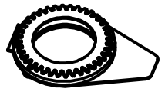
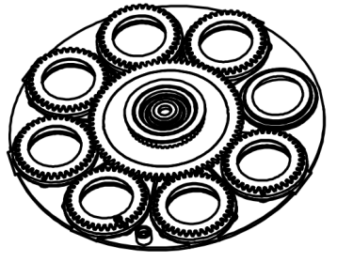
③Use tweezers or other small graspable objects to take out the circlip at B. Please use professional tools to remove the circlip to avoid damage to the gobo.
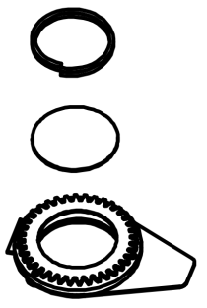
B

- Installation and connection
  - Installation diagram
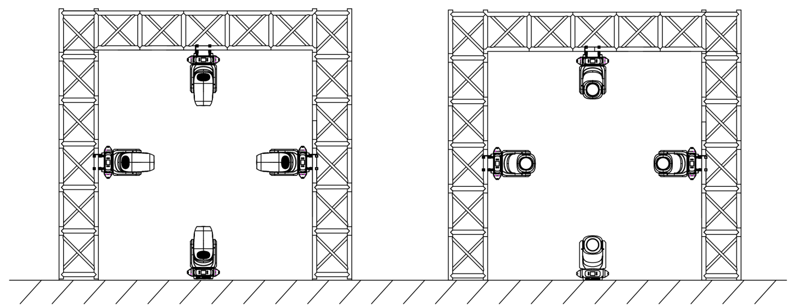
SAFETY CABLE
CLAMP
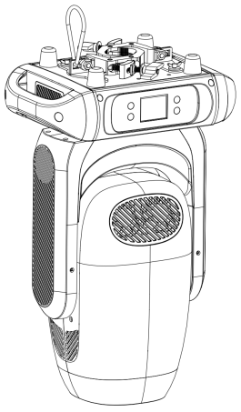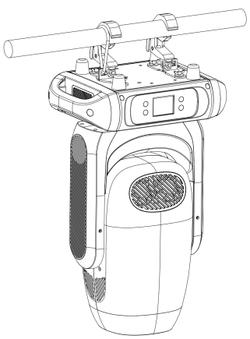

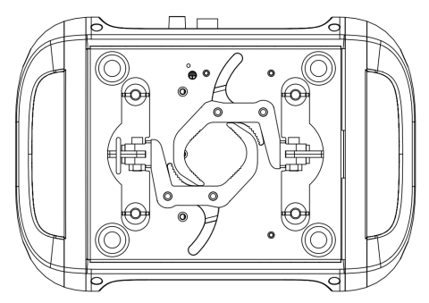
  - Fixed clamps Install
Safety rope attachment point
OMEGA BRACKET ATTACHMENT POINTS

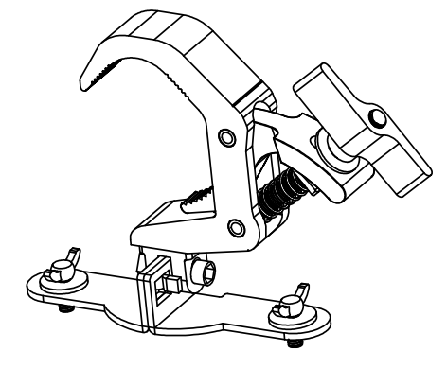

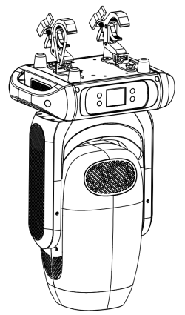
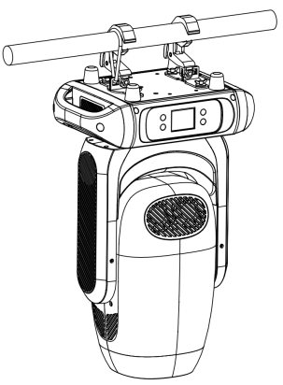
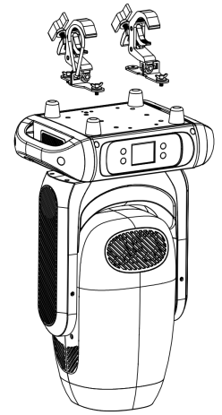

  - Luminaire size after installation
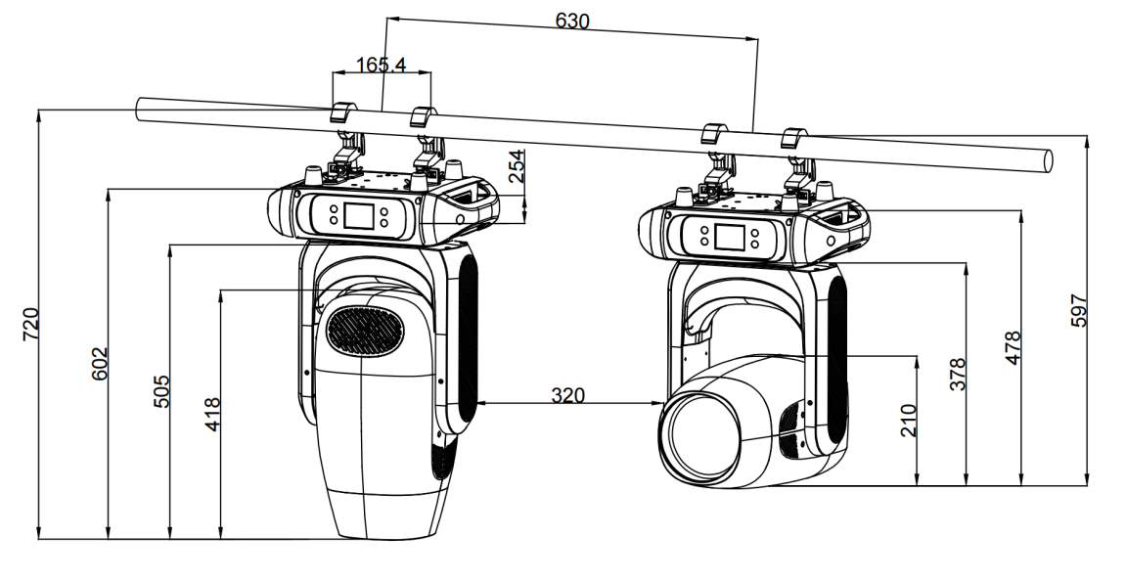

  - Precautions
- This product is only suitable for indoor use, and its protection level is IP20. The lamp should be kept clean, and should not be used in a humid or dusty environment. It should be maintained every three months.
- Only qualified professionals can install, operate and maintain the lamps, and ensure that the operation is strictly in accordance with the procedures described in this manual.
- The lamps and lanterns should be installed in a well-ventilated place, at least 50CM away from the wall, and check whether the ventilation holes are unobstructed. Do not look directly at the light source to avoid damage to the eyes.
- Parts that make electrical connections must be operated by qualified installers.
- Each lamp should be safely grounded, and electrical installation should be carried out in accordance with relevant standards.
- Do not use the power cord whose insulation layer has been damaged, and do not put the power cord on other wires. When the lamp is not in use or cleaned, please unplug the power cord. Do not pull or pull the power cord vigorously.
- If the back cover of the lamp is equipped with a safety buckle or a connection hole, for safety reasons, please use the safety rope to pass through the connection hole for auxiliary hoisting.

  - Power l Connection
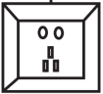
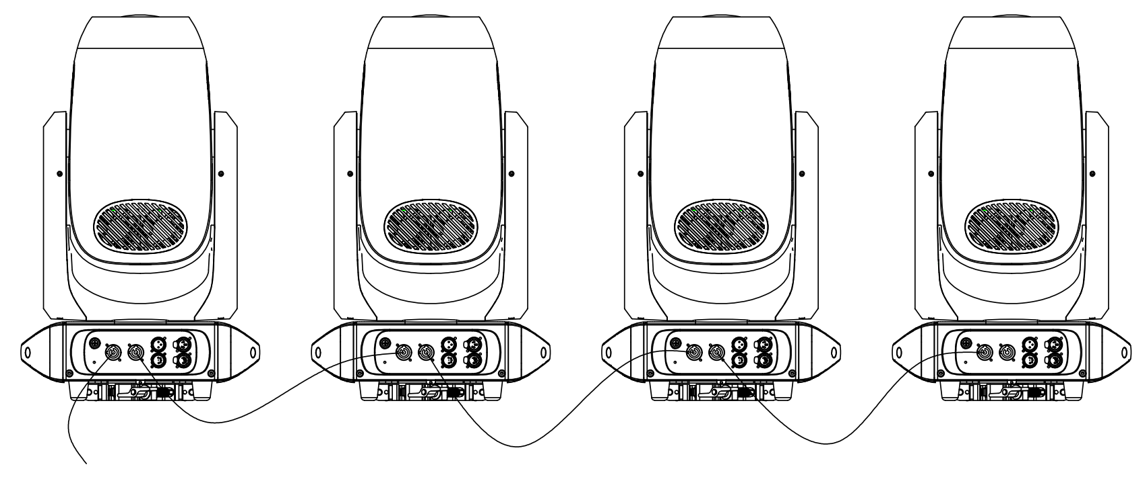

- The standard product uses Powercon in /out, a single connection power cord.
- Note: Due to power reasons, a 1.5 square power cord can carry up to 2-4 units (220V).

Do not connect too many lamps to a single power cord, or overload it.
Do not use the power cord with damaged insulation, and do not put the power cord on other wires.
When the lamp is not in use or cleaned, please unplug the power cord.
Do not pull or plug in vigorously or drag the power cord directly.

7.6 Signal Connection
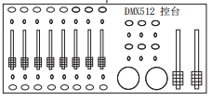
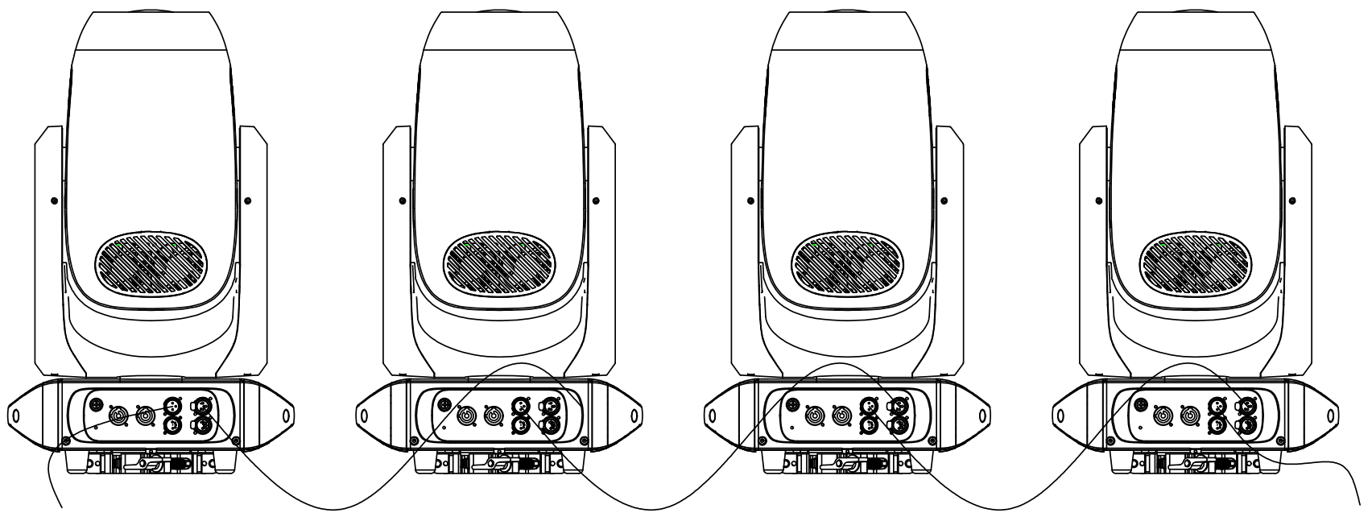
The Next

7.7 Signal Connection illustrate
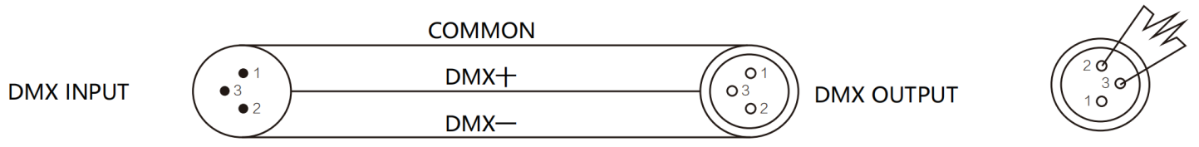
- Please use a shielded twisted-pair cable configured for DMX512. The DMX input and output of the device adopt 3-pin or 5-pin XLR connection socket.
- Pin1：GND，Pin2：Signal（-），Pin3：Signal（+）
- At last unit, the DMX cable has to be terminated with a terminator. Solder a 120-ohm 1/4W resistor between pin 2(DMX-) and pin 3(DMX+) into a 3-pin XLR-plug and plug it in the DMX-output of the last unit
- Connect the unit together in a “daisy chain” by XLR plug cable from the output of the unit to the input of the next unit. The cable can only be used in series and cannot be connected in parallel. DMX 512 is a very high-speed signal. Inadequate or damaged cables, soldered joints or corroded connectors can easily distort the signal and shut down the system.
- The DMX output and input connectors are pass-through to maintain the DMX circuit, when one of the units’ power is disconnected.
- Each lighting unit needs to have a DMX address to receive the data by the controller. The address number is between 1-512.
- Each lamp must have an address code, which can receive the information sent by the console.
- The end of the DMX 512 system should be terminated to reduce signal errors.
- Connect the fixtures with Max.11 pieces. Make sure to insert the "signal in" terminal in the last connecting fixture.

7.8 Ethernet connection
- The data communication is provided with Art-Net protocol，thus the controll-ing utilities used in the lighting controller or PC must support such protocol. The maximum transferring speed can reach 10Mb/s.
- The fixture is provided with 8-pin RJ-45 connector for internet input. Please use class 5 cables and standard RJ-45 connector for internet connection，Shown as Fig.
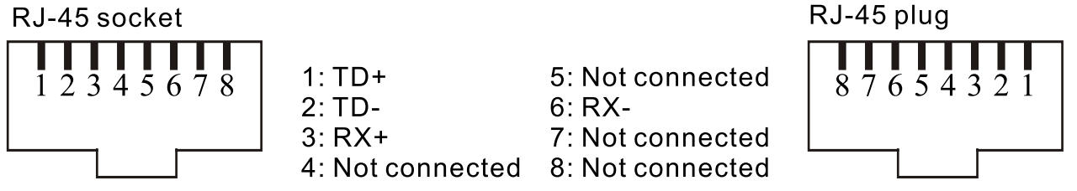

- Type A IP address is configured as default addresses.

7.9 Ethernet connection layout，shown as Fig.
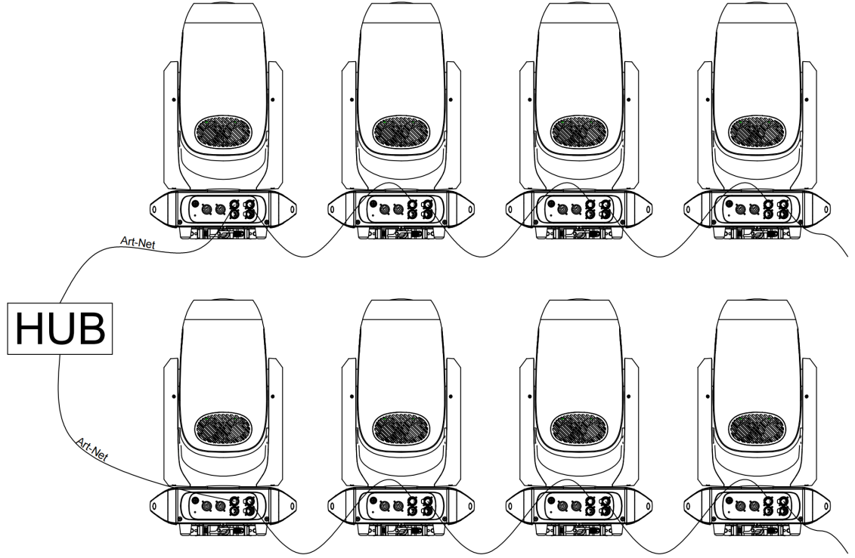

Connection method ONE
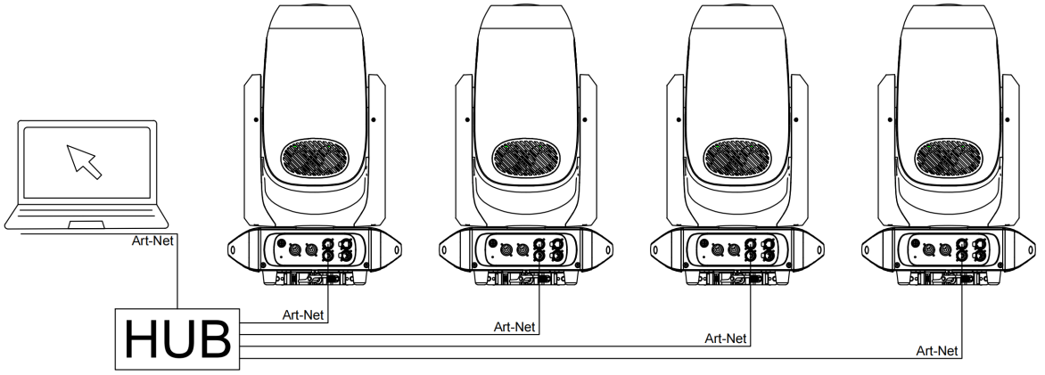

Connection method TWO

7.10 DMX set
- If you use a universal DMX controller to control the units, you have to set DMX address from 1 to 512 so that the units can receive DMX signal.
- Press the〔MODE/ESC〕button to enter menu mode, select DMX Settings, press the 〔ENTER〕 button to confirm, use the〔UP/DOWN〕button to select DMX Address, press the〔ENTER〕 button to confirm, the present address will blink in the display, use the〔UP/DOWN〕button to adjust the address from 001 to 512, press the〔ENTER〕button to store. Press the 〔MODE/ESC〕 button back to the last menu or let the unit idle 30 seconds to exit menu mode.
Channel mode | Unit 1 Address | Unit 2 Address | Unit 3 Address | Unit 4 Address
36 channels | 1 | 37 | 73 | 99
34 channels | 1 | 35 | 69 | 103
56 channels | 1 | 57 | 113 | 169

- Error Information
- Error codes are shown continuously in the display when the fixture fails and they will not disappear until the fixture is repaired.
- Pan Reset Error

Check whether the position of the pan where the magnet is installed falls off or is damaged.

Check whether there are obstacles in the pan operating range.

Check whether the Hall element on the pan is damaged.

Check whether the lead connecting the Hall element on the pan and the PCB board is in poor contact or disconnected.

Check whether the motor on the pan is damaged.

Check whether the related circuit of the motor drive board on the pan is damag.

① Pan/Tilt Encode Error

Check whether the encoder on the pan is damaged.

Check whether the lead connecting the encoder on the pan and the PCB board is in poor contact

③ Tilt Reset Error

Check whether the position of the tilt where the magnet is installed falls off or is damaged.

Check whether there are obstacles in the tilt operating range.

Check whether the Hall element on the tilt is damaged.

Check whether the lead connecting the Hall element on the tilt and the PCB board is in poor contact or disconnected.

Check whether the motor on the tilt is damaged.

Check whether the related circuit of the motor drive board on the tilt is damage.

④ Color Reset Error

Check whether the position of the color wheel where the magnet is installed falls off or is damaged.

Check whether there are obstacles in the color wheel operating range.

Check whether the Hall element on the color wheel is damaged.

Check whether the lead connecting the Hall element on the color wheel and the PCB board is in poor contact or disconnected.

Check whether the motor on the color wheel is damaged.

Check whether the related circuit of the motor drive board on the color wheel is damage.

⑤ Gobo Reset Error

Check whether the position of the gobo wheel where the magnet is installed falls off or is damaged.

Check whether there are obstacles in the gobo wheel operating range.

Check whether the Hall element on the gobo wheel is damaged.

Check whether the lead connecting the Hall element on the gobo wheel and the PCB board is in poor contact or disconnected.

Check whether the motor on the gobo wheel is damaged.

Check whether the related circuit of the motor drive board on the gobo wheel is damage.

⑥ Prism Reset Error

Check whether the position of the prism where the magnet is installed falls off or is damaged.

Check whether there are obstacles in the prism operating range.

Check whether the Hall element on the prism is damaged.

Check whether the lead connecting the Hall element on the prism and the PCB board is in poor contact or disconnected.

Check whether the motor on the prism is damaged.

Check whether the related circuit of the motor drive board on the prism is damage.

⑦ Focus Reset Error

Check whether the position of the focus where the magnet is installed falls off or is damaged.

Check whether there are obstacles in the focus operating range.

Check whether the Hall element on the focus is damaged.

Check whether the lead connecting the Hall element on the focus and the PCB board is in poor contact or disconnected.

Check whether the motor on the focus is damaged.

Check whether the related circuit of the motor drive board on the focus is damage.

⑧ Zoom Reset Error

Check whether the position of the focus where the magnet is installed falls off or is damaged.

Check whether there are obstacles in the focus operating range.

Check whether the Hall element on the focus is damaged.

Check whether the lead connecting the Hall element on the focus and the PCB board is in poor contact or disconnected.

Check whether the motor on the focus is damaged.

Check whether the related circuit of the motor drive board on the focus is damage.

⑨ Led Temp. Error

Check whether the temperature detecting board is normal.

Check whether the components of the temperature detecting board are damaged.

Check whether the lead on the temperature detecting board is installed in place or disconnected.

⑩ LED Too Hot Off
When the fixture temperature reaches 90℃, it will automatically turn off to protect the fixture.
- Troubleshooting
Symptoms | Cause of issue | Approach
No menu displayed | 1. No AC input  2. The switching power supply is damaged  3. Display board failure | 1. Check the power supply line  2. Check whether the switching power supply has voltage output  3. Replace the display board
Can't receive DMX signal | 1. DM signal line failure  2. The wiring sequence of the signal line is wrong  3. The IC receiving the signal at the signal input terminal is damaged  4.4. The DMX address code setting does not match the corresponding control of the console  5. Other parameters are set incorrectly  6. After entering the menu without pressing the confirm button | 1. Check or replace the signal line  2. Check the wiring sequence of the signal lines  3. Check whether the signal receiving IC of the display board and the two resistors connected in series on the signal line are open  4. Check or reset the address code or restore the factory settings and try again  5. Press MENU to exit to the main menu
The surface temperature of the lamp body exceeds 90°C and cannot be protected by temperature control | 1. The thermistor on the light source board is faulty  2. The temperature control circuit on the display board is faulty | 1. Replace the thermistor  2. Check the temperature control circuit on the motherboard
Uneven color mixing of light spots, uneven color spots | 1. Improper welding of light source  2. The lens or bracket is not installed properly | 1. Check the bulb welding condition  2. Check the lens assembly process and adjust the assembly direction of the bracket
The light source is off or flickers slightly | The light source is damaged or the driver board has no current output | 1. Replace the light source  2. Replace the damaged light source or check the driver board circuit  3. Replace the corresponding driver IC
The whole lamp does not work when it is powered on | When the temperature is too high, the temperature control protection causes the over-temperature protection of the switching power supply to not work | 1. Wait for the lamp body to cool down before turning it on

10.Equipment maintenance and cleaning

10.1 Cleaning Precautions

Routine cleaning and maintenance are required. The service life of the equipment depends largely on the operating environment. Please consult a professional for advice.
Excessive dust，smoke fluid and particulate bildup will degrade performance ad cause over heating or damage to the fixture tha is not covered by the warranty. Please unplug the fixture before you open any covers.

- Cleaning

①Optical components should be cleaned carefully and lightly. Coating face is easily damaged，do not use harmful solvent so as to avoid damage to plastic parts or coating parts.

②Clean the external optical lens at least every 20 days and the internal optical lens every 30 days.
- Cleaning optical components

①Switch off the fixture and keep it cool completely，then open the cover.

②Clean the floats by dust collector or compressed.

③Use cotton paper without smell or cotton cloth soaked with the water，distilled water to wipe the granular thing，don't wipe the surface，float thing should be blown away by the pressure gas.

④Use the cotton cloth or cotton paper without smell soaked with isopropyl alcohol to remove the smoke and other residuse. A commercial glass cleaner may be used，but residuse must be removed with distilled water. Clean with a slow cirular motion from center to edge. Dry with a clean，soft and lint-free cloth or comperessed air.
- Cleaning fan and air vents

①Remove dust from the fans and air vents with a soft brush，cotton paper，vacuum，or compressed air.

10.2 Head filter sponge cleaning

①Disconnect the power supply, unscrew the four screws at A on the left and right of the shell with a screwdriver, and take out the head cover；

②Use a screwdriver to unscrew the two screws at B on the left and right sides of the head cover, and take out the sponge；

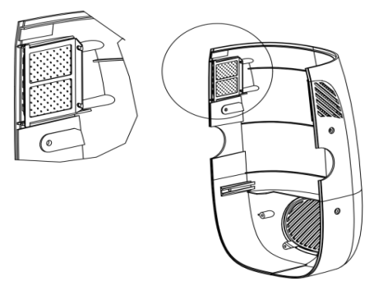
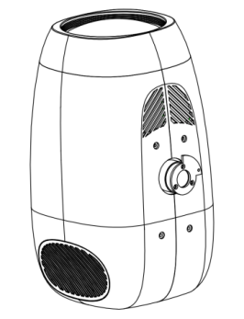
B
A

③Take out the fixing bracket along the direction of the arrow；

④Take out the filter sponge in the direction of the arrow；

⑤Gently blow off the dust and floating objects with a vacuum cleaner or a pressure blower. If it is serious, please replace the filter cotton of the same type；
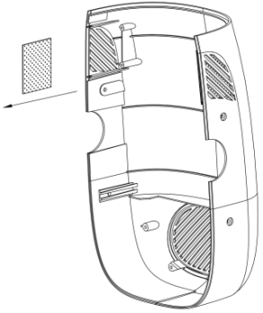
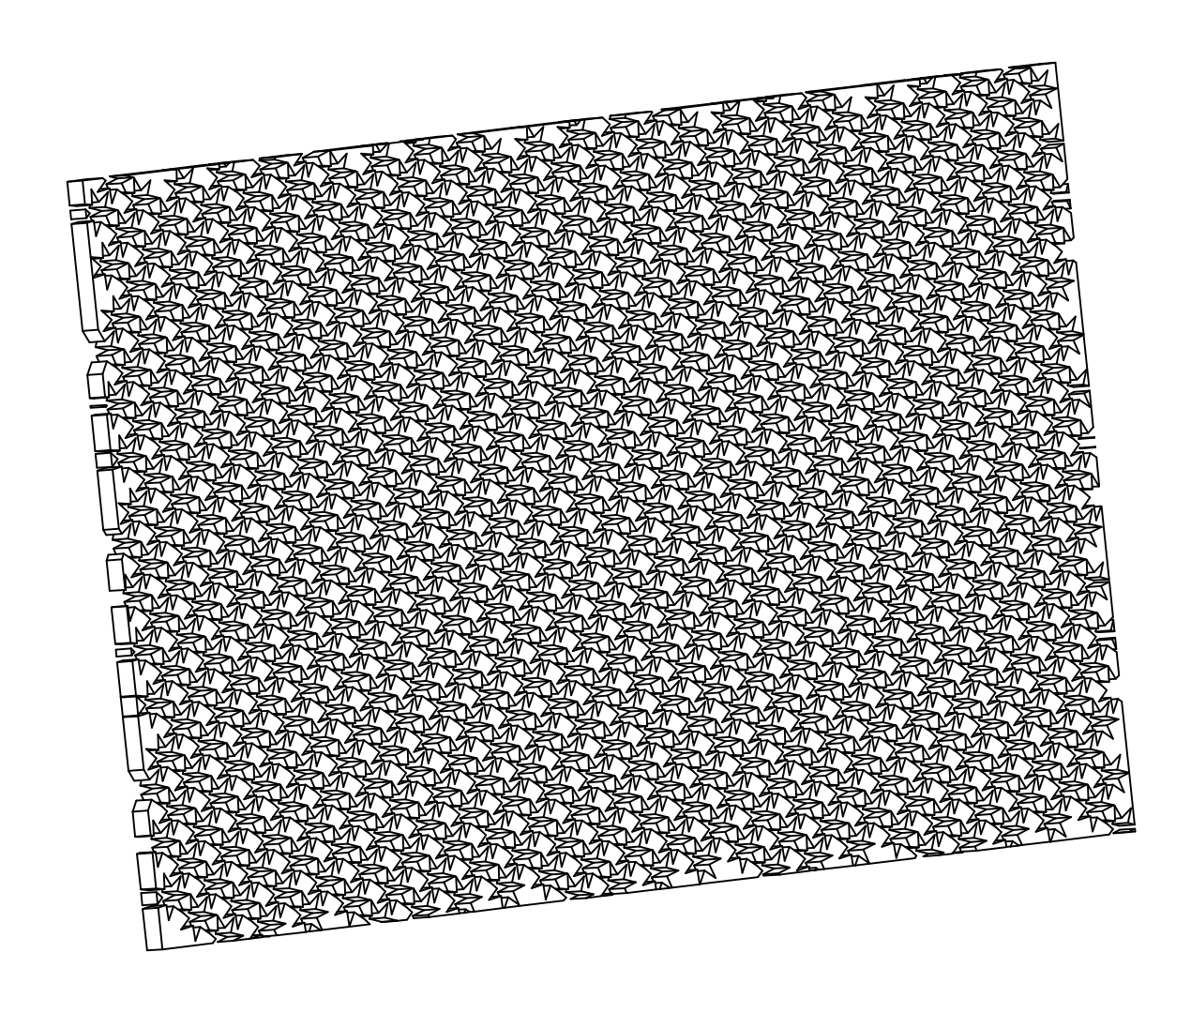
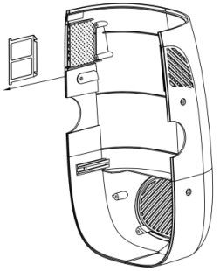

10.3 Base filter sponge cleaning

①Open the buckle along the direction A, and pull out the baffle in the direction B；

②Open the baffle along direction C and take out the filter sponge；

③Gently blow off the dust and floating objects with a vacuum cleaner or a pressure blower. If it is serious, please replace the filter cotton of the same type；
